**SMART PARKING**

**Sensors :**

**Infrared sensor**

**Dataset ;**

**To create a dataset for a smart parking system, you’ll need to collect various types of data related to parking spaces and their availability. Here’s a list of data you might consider collecting:**

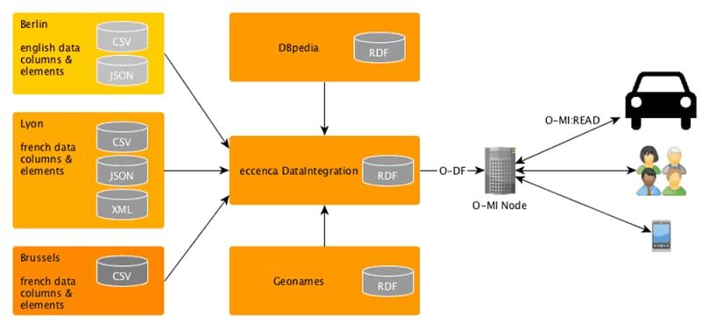

**1. Parking Space Information:**

**-GPS coordinates of parking spaces.**

**- Type of parking space (e.g., street parking, garage, lot).**

**- Capacity of each parking space.**

**2. Real-Time Availability Data:**

**- Occupancy status (available, occupied, reserved) of each parking space.**

**- Timestamps indicating when the status changes.**

**- Duration of occupancy.**

**3. Vehicle Information:**

**- License plate numbers of parked vehicles.**

**- Vehicle type (e.g., car, motorcycle, truck).**

**- Vehicle color.**

**4. User Information:**

**- User ID or session information for those who reserve or use parking spaces.**

**- Duration of parking sessions.**

**5. Payment Information:**

**- Transaction data for payments made for parking.**

**- Payment method used (credit card, mobile payment, cash).**

**6. Environmental Data:**

**- Weather conditions (temperature, precipitation) that might affect parking availability.**

**- Traffic conditions near the parking spaces.**

**7. Camera or Sensor Data:**

**- Images or video footage from parking area cameras.**

**- Sensor data (e.g., ultrasonic or infrared sensors) for occupancy detection.**

**8. Historical Data:**

**- Past parking availability data for analysis and predictions.**